Logbook 04/08/2026
- Scib ran, but we cannot compare it to Samuel’s scores, since they were normalized differently add Samuel’s Harmony integration to the comparison, which needs to be extracted from the massive .rds object
- Added Clint’s annotations to the Harmon_RNA object to compare to Samuel’s annotations

“experiment”
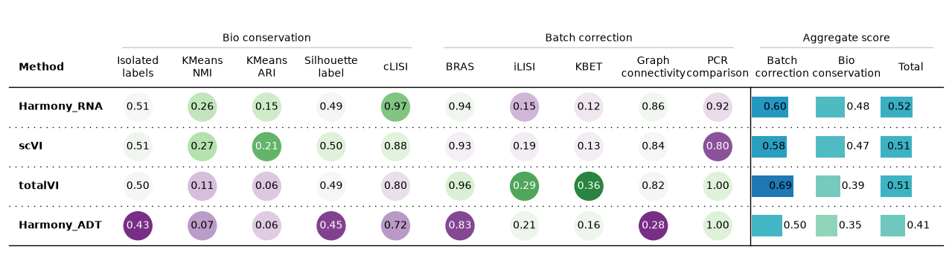
“orig.ident”
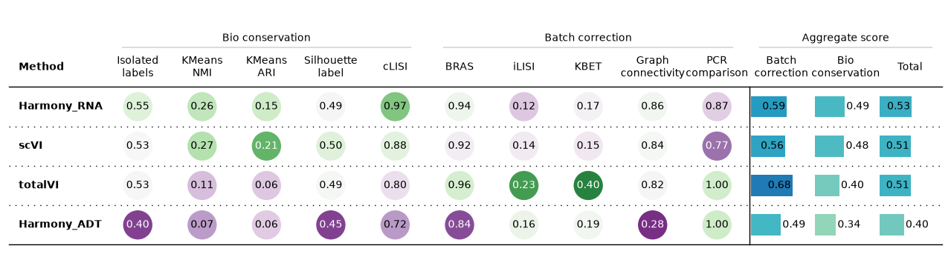

- Extracted the Harmony integration from Samuel and ran scib-metrics on that

TODO
- Harmonize annotation
- scANVI
- scANVI –> SAM2 and/or 3
- then decide which annotation/ integration is the best

Samuel changed his annotation last min, Annot3 is the right object, so update celltypes

